Project 1: Evaluation of AWS Discovery Service Data
Matthew Santiago
University of Maryland Global Campus
CCS 640 Cloud Computing Implementations and Migrations
Charlie Shao
April 21, 2025

Overview
In this evaluation, we will review the analytic data from our servers to determine what Amazon Web Service product would be the recommended service to migrate to. The following will detail the processes captured on the server, what those processes are dependent on, and the performance metrics of the server.
AWS Discovery Service
In this evaluation, we will use AWS Application Discovery Service to discover BallotOnline on-premises servers. The AWS Application Discovery Service will allow BallotOnline to analyze servers, the applications and dependencies in order to properly migrate them through the Migration Hub (Amazon Web Services, 2025). The AWS Application Discovery Service provides two main data collection approaches: agent-based and agentless discovery (Amazon Web Services, 2025). Next we will provide an overview of both discovery options.
Using the agent based discovery option we will need to install the software on each server in order for the discovery to work. The software gathers detailed data about the system, performance, network connections and running processes (Amazon Web Services, 2025). By using this option we will be able to analyze detailed resource utilization and application dependency information which will allow us to determine which systems need to be retired or migrated before starting the migration. A downfall of using this option is we will need to install the agent on servers manually which can be tedious in a large data center and increase the time needed to begin migrating (Amazon Web Services, 2025).
Using the agentless discovery option is a way to gain server information without installing software. This is done by using VMware vCenter to pull information once the agentless collector is configured (Amazon Web Services, 2025). This option is a great way to perform premigration data analysis if the organization uses VMware vCenter. Using this option provides about the same information as the agent-based collector but in a quick easy set up. Although this can be a quick and easy set up this option has one big limitation, it only works with VMware vCenter (Amazon Web Services, 2025). So if the organization does not have VMware vCenter, they will not be able to use this service and have to proceed with agent based discovery.
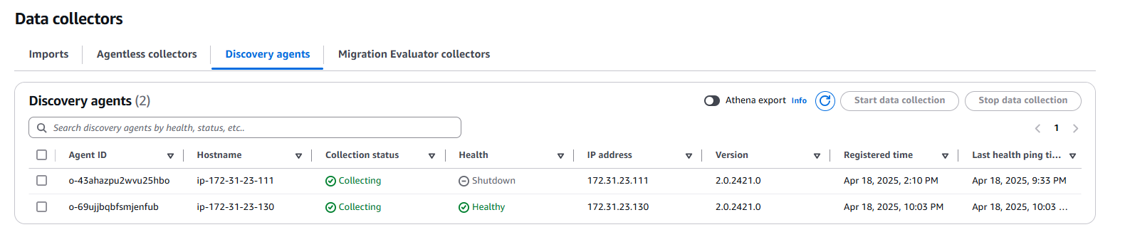
Analysis
From the data collected from the data collector in AWS Discovery Service we will analyze the data. The analysis will be done by identifying the processes, mapping the dependencies and identifying the performance metrics. First, the following processes were seen running on the server: Apache HTTP Server, MySQL Database Server, SSH Daemon, AWS Discovery Agent and various system services. Second, the application dependencies are as follows: Apache HTTP Server depends on PHP, the PHP depends on MySQL Database, and SSH is needed for remote login. Third, the performance metrics are: CPU utilization: 0.57%, Disk usage: 0.0025 Kbps read, 0.69 Kbps write, Network I/O: 0.15 Kbps read, 0.25 Kbps write, Total disk space: 7.75 GB, 6.07 GB available, RAM: 2 GB total.
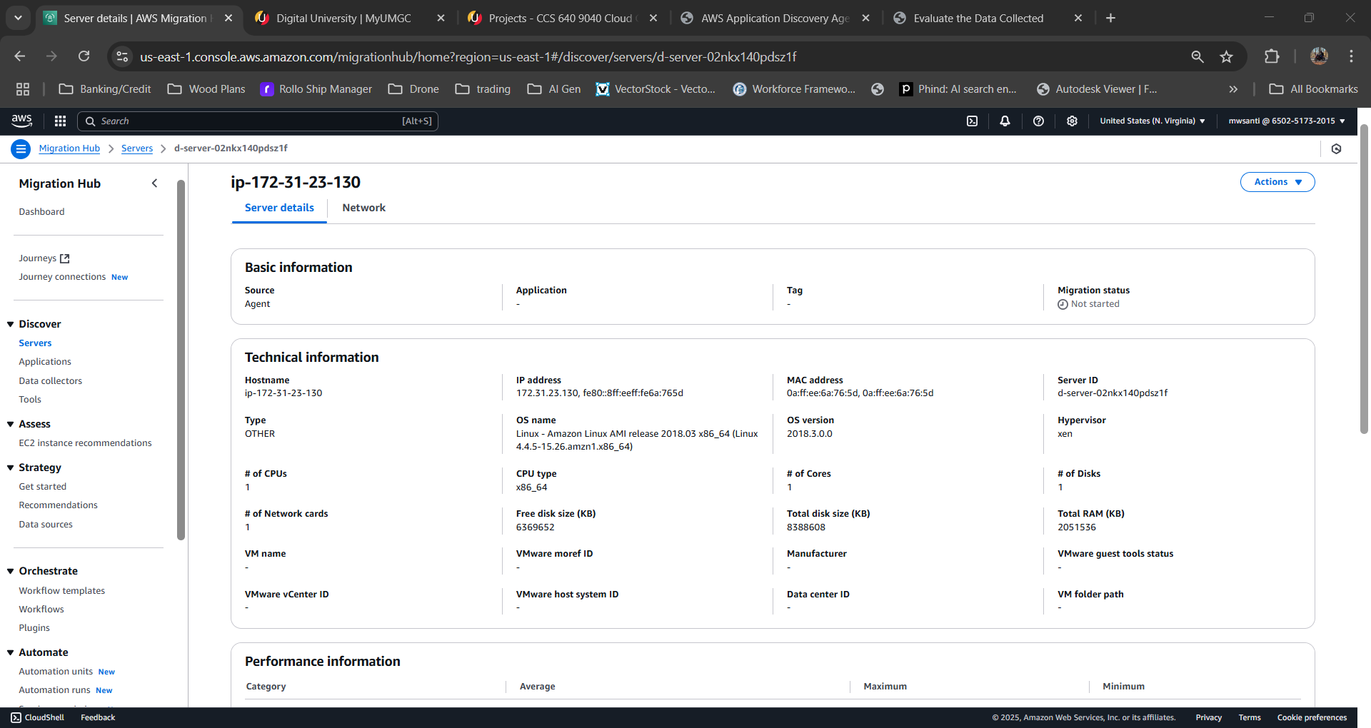

Recommendation
In our opinion for the migration of this BallotOnline system, we recommend AWS Elastic Beanstalk. This recommendation is due to Elastic Beanstalk ease of use and control. Amazon Web Services states, “Elastic Beanstalk reduces management complexity without restricting choice or control” (Amazon Web Services, n.d.). Elastic Beanstalk provides a straightforward deployment of existing applications by “automatically handl[ing] the details of capacity provisioning, load balancing, scaling, and application health monitoring” (Amazon Web Services, n.d.). The service will enable our applications to quickly migrate and initialize in a secure environment that will automatically scale when needed. This will reduce the workload on IT personnel during the migration but also still give our administrators the control needed to modify infrastructure during or later to meet BallotOnline requirements as we continue the migration process.

References
Amazon Web Services. (2025). AWS Application Discovery Service. Retrieved from Amazon Web Services: https://docs.aws.amazon.com/pdfs/application-discovery/latest/userguide/appdiscovery-ug.pdf
Amazon Web Services. (2025). What is AWS Application Discovery Service? Retrieved from Amazon Web Services: https://docs.aws.amazon.com/application-discovery/latest/userguide/what-is-appdiscovery.html
Amazon Web Services. (n.d.). What is AWS Elastic Beanstalk? Retrieved from Amazon Web Services: https://docs.aws.amazon.com/elasticbeanstalk/latest/dg/Welcome.html

